HSE Monthly Report – March 2026
Weyland Energy – all sites
Hannah Weber · 08 April 2026 · HSE-RPT-2026-03

1. Headlines
Lost time injury on 19 March at Altmark (HSE-INC-2026-007): a contractor technician fractured his ankle stepping off the ladder rest platform in a tower. Investigation found a missing anti-slip strip; all ladder platforms of this turbine type are being checked. Harrow Bay offshore readiness: HSE review of the MV Sea Atlas safety management system and bridging document completed. GWO refresher training for 46 contractor staff at Port of Eastholm.
Indicator | March | YTD 2026 | 2025
Hours worked | 150,000 | 404,000 | 1,452,000
Lost time injuries | 1 | 1 | 2
Recordable injuries | 1 | 2 | 6
First aid cases | 4 | 14 | –
Near misses | 32 | 88 | 307
Safety observations | 221 | – | –
LTIFR rolling 12 months | 1.32 | – | 1.38
TRIR rolling 12 months | 4.61 | – | 4.13

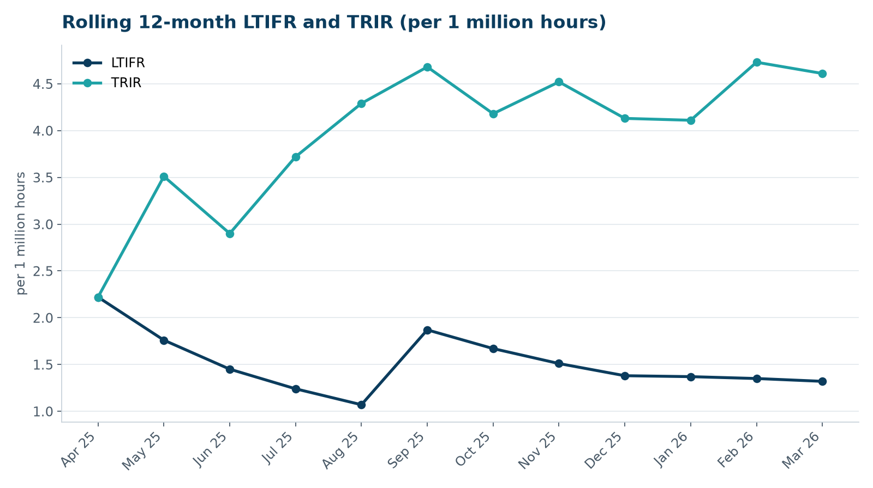

2. Hours by group
Group | Hours | Share
Weyland employees | 63,000 | 42 %
O&M contractors (operating assets) | 43,000 | 29 %
Harrow Bay contractors | 44,000 | 29 %

3. Leading indicators
- Toolbox talks delivered: 99
- Management safety walks: 18 (target 12)
- Inspections of lifting equipment: 43
- Open corrective actions older than 30 days: 3

4. Focus for next month
Fatigue management for offshore crews during long weather windows.
Hannah Weber, HSE Manager

